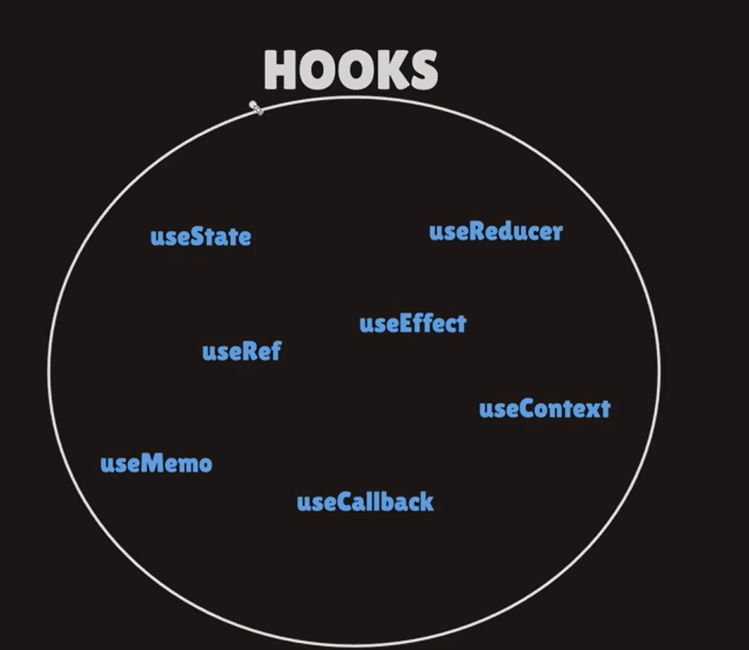

useState -> used to manage state
input is empty -> ek state
input mein s likh diya -> dusri state
input mein a likh diya => now input contains sa -> teesri state
ab ye jo states change ho rahi hai wo useState se ho rahi hai.

useEffect -> manages side stack.
Main road pe gaadi chal rahi hai.
X person apni cycle leke side(footpath) se nikal gaya.
Api ko call karke data lena -> here we will use useEffect.

useRef -> document.querySelector in js is used to select some tag
ab react chahta hai ki react ke through sab kuch ho -> yaha pe useState kaam mein aata hai, react ke through changes karne mein.
useRef -> kisi ki reference lene mein help karata hai. Yaha pe document,querySelector nahi use karte/

useContext -> manages global context.
Using context api’s we send the common data to all the files who need that.
Instead of sending it through different sections, we are directly sending it globally to everywhere. Used in managing dark and light themes.
useReducer –> complex logics management(changes in array, check whether the user is authenticated or not).
usecontext -> simple management.

useState(basic state management) ka advance version -> useContext(global level management) and iska advance version -> useReducer(complex global logic management).

useMemo -> memoization
useCallback -> with home lets say about changed, and some more changed => re render ho rahi hai => load aa raha hai.
Toh useMemo and useCallback -> used in optimization.
